4. Computer Arithmetic
4.1 Integer Representation: (Fixed-point representation):
An integer can be positive, negative and zero. While representing the integer in digital number system, we change them into a pattern of 0s and 1s called binary number system.
In general, the binary number can be represented in two ways:
- Unsigned Binary Numbers
- Signed Binary Numbers

- Unsigned Binary Numbers
Only positive integers can be represented.
There is no need of sign bit here.
All the n-bits are used to represent the magnitude of number based on the positional weights.

For example:
Let us consider a positive integer = +12
The unsigned binary number = 1100

- Signed Binary Numbers
Both positive and negative integers can be represented.
Sign bit is needed, the MSB is a sign bit
For positive integers, the sign bit (MSB) is 0
For negative integers, the sign bit (MSB) is 1

For example:
Let us consider a positive integer = +12
The signed binary number for +12 = 01100
Also, for a negative integer = $-$12
The signed binary number for $-$12 = 11100

There are three different ways the signed binary numbers can be represented
- Signed magnitude representation
- 1’s complement representation
- 2’s complement representation

4.1.1 Sign magnitude representation:
In sign-magnitude representation, the MSB of the number is a sign bit and the remaining bit represents the magnitude of the number.
For example, if some signed number is represented in the 8-bit sign-magnitude form then MSB is a sign bit and the remaining 7 bits represent the magnitude of the number in a true binary form.
Here is the representation of + 34 and -34 in an 8-bit sign-magnitude form.
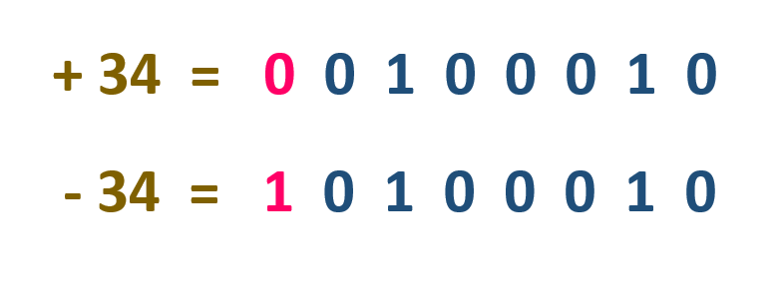
Since the magnitude of both numbers is the same, the first 7 bits in the representation are the same for both numbers. For +34, the MSB is 0, and for -34, the MSB or sign bit is 1.
The general case can be expressed as follows:
A = $\sum_{i=0}^{n-2}{2^{i}a_{i}}$ if a_{n-1} = 0 .
= $-\sum_{i=0}^{n-2}{2^{i}a_{i}}$ if a_{n-1} =1

Drawback:
- Addition and subtraction requires the consideration of both signs and their relative magnitude

- Two different representations for 0.

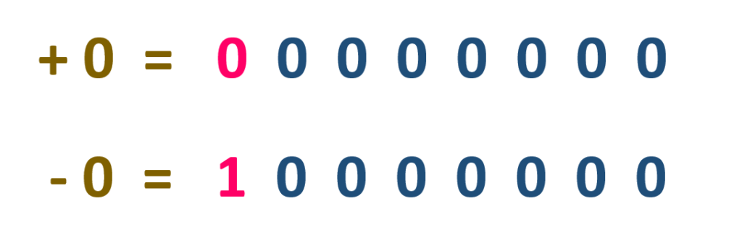
4.1.2 2’s complement representation:
In 2’s complement representation, the representation of the positive number is same as sign – magnitude representation.

That is, for a positive number in 2’s complement,
The sign bit is 0.
the magnitude is given by:
A = $\sum_{i=0}^{n-2}{2^{i}a_{i}}$ if a_{n-1} = 0 .

The number zero is identified as +ve
And therefore, has zero sign bit and magnitude of all 0’s.

Now,
The negative number in 2’s complement,
The sign bit is 1.
And the magnitude is given by
A = $-$2^{n-1}a_{n-1}$+\sum_{i=0}^{n-2}{2^{i}a_{i}}$ if a_{n-1} = 0 .

Defines the twos complement of representation of both positive and negative number.
E.g
Decimal |  | Sign magnitude |  | Twos complement
 |  | representation |  | representation
+7 |  | 0111 |  | 0111
-7 |  | 1111 |  | 1001
- Eight-position twos complement value box.

-128 | 64 | 32 | 16 | 8 | 4 | 2 | 1

- Convert 10000011 to decimal

-128 | 64 | 32 | 16 | 8 | 4 | 2 | 1
1 | 0 | 0 | 0 | 0 | 0 | 1 | 1

-128 +2 +1 = -125

- Convert decimal -120 to binary

-128 | 64 | 32 | 16 | 8 | 4 | 2 | 1
1 |  |  |  | 1

-120 =-128 +8
-120 = 1000100
Fig. Use of value box for conversion between 2’s complement binary and decimal.

4.2 Integer arithmetic:
Negation: N bit a sequence of binary digit a_{n-1} a_{n-2}….a₁ a_{o} as twos complement integer A. So that its value,
- = -2n-1an-1+ ∑n-2i=02iai
Now form the bit wise complement a_{n-1}(comp)a_{n-}
2(comp)….a₁(comp)a_{o}(comp) and treating this unsine integer and add 1. Finally interpreter the result in n bit sequence of binary digit as tows complement integer B. So that its value is
- = -2n-1an-1(comp)+∑n-2i=02iai(comp)
Now we want, A = -B which means A+B=0
A+B = -2n-1an-1+ ∑n-2i=02iai-2n-1an-1(comp)+∑n-2i=02iai(comp)+1
= -2n-1(an-1+an-1(comp))+∑n-2i=02i(ai+ai(comp))+1
= -2n-1+∑n-2i=02i = -2n-1+1+2n-1-1 = 0
4.3 Addition and Subtraction:

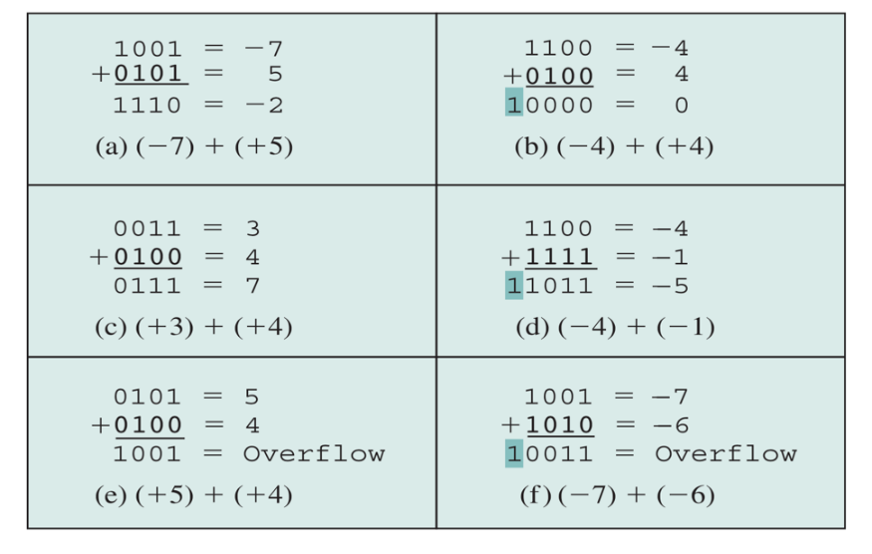

Fig: Addition of numbers in Twos Complement Representation

The first four examples illustrate successful operation if the result of the operation is +ve then we get +ve number in ordinary binary notation. If the result of the operation is –ve we get negative number in twos complement form. Note that in some instants there is carry bit beyond the end of what which is ignore. On any addition the result may larger then can be held in word size being use. This condition is called over flow. When overflow occur ALU must signal this fact so that no attempt is made to use the result. To detect overflow the following rule observed. If two number are added, and they are both +ve or both –ve. Then overflow occurs if and only if the result has the opposite sign.
The figure suggest the data path and hardware elements need ot accomplish addition and subtraction.

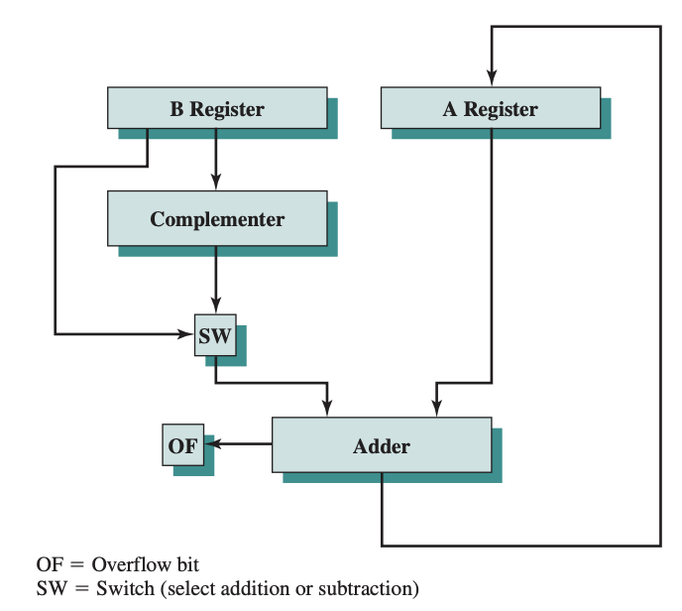

Fig: Block diagram of hardware for subtraction and addition.

4.4 Unsigned Binary Multiplication Algorithm:
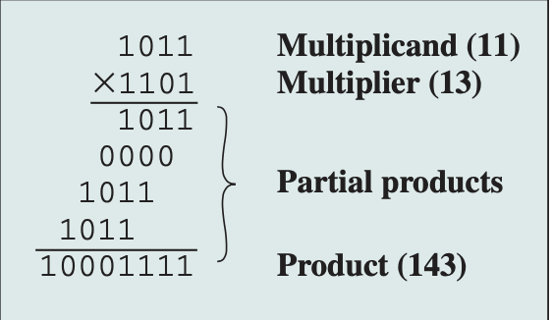

Fig. Multiplication of unsigned binary integers.
- The multiplication involve the generation of partial product 1 for each digit in the multiplier. This partial products are then sum to produce final product.
- The partial product are easily define. when the multiplier bit is zero the partial product is zero. When the multiplier is 1 the partial product is the multiplicand.
- The total product is produce by summing the partial products. For this operation each successive partial product is shifted one position to the left relative the perceiving partial product.
- The multiplication of two n bit binary integer results in product of upto 2n bits in length. Eg. 11 ×11= 1001

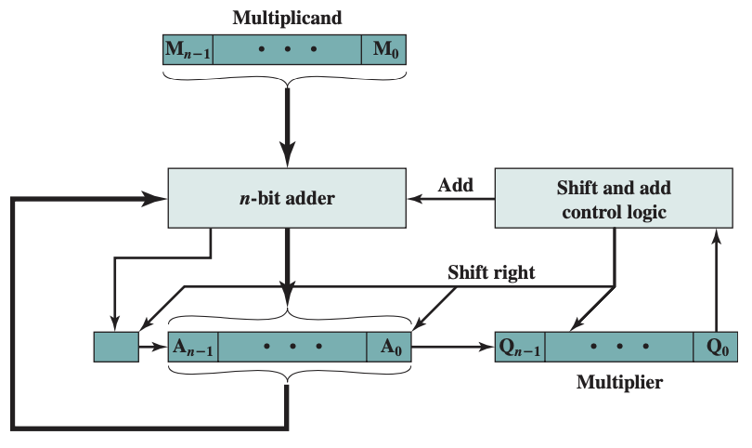
Fig: (a) Block diagram for Unsigned Multiplication

Count | C | A | Q (13)₁₀ | M (11)₁₀ | Remarks
4 | 0 | 0000 | 1101 | 1011 | Initial values
3 | 0 | 1011 | 1101 | 1011 | Add; A A+M  Logical Right Shift
3 | 0 | 0101 | 1110 | 1011 | Add; A A+M  Logical Right Shift
2 | 0 | 0010 | 1111 | 1011 | Logical Right Shift
1 | 0 | 1101 | 1111 | 1011 | Add; A A+M  Logical Right Shift
1 | 0 | 0110 | 1111 | 1011 | Add; A A+M  Logical Right Shift
0 | 1 | 0001 | 1111 | 1011 | Add; A A+M  Logical Right Shift
0 | 0 | 1000 | 1111 | 1011 | Add; A A+M  Logical Right Shift

1011 X 1101 = 1000 1111
i.e. (13)₁₀ X (11)₁₀ = 128+8+4+2+1 = (143)₁₀

Process:
Control logic reads bits of multiplier one at a time. If Q0 is 1 the multiplicand is added to A register and result is stored in A register with C bit used for overflow then all of the bits of C , A , and Q register are shifted to the right one bit so that C bit goes into A_{n-1}, A₀ goes into Q_{n-1} and Q₀ is lost. If Q₀ is zero and no addition is perform , just the shift. This process is repeated for each bit of the original multiplier. The resulting 2n bit product is contain in A and Q register. A flow chart of the operation is shown in fig.

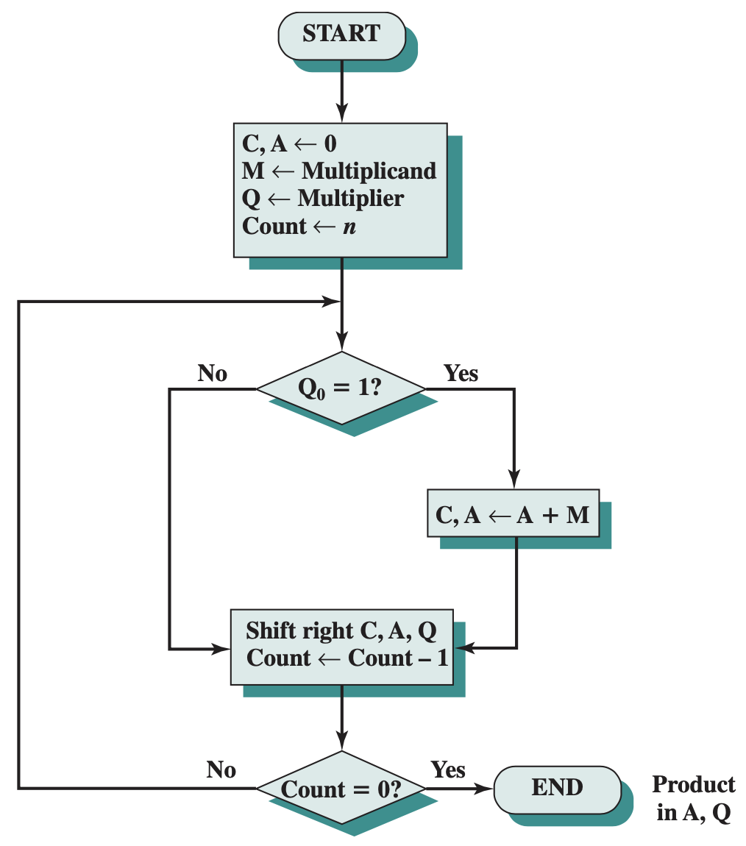

Fig: Flowchart for Unsigned Binary Multiplication

4.5 Booth’s Algorithm for multiplication (2’s Complement multiplication)

If we multiply 11 (1011) by 13 (1101) we get 143 (10001111). If we interpret this as two’s complement numbers we have, - 5 (1011) times -3 (1101) equals -113(10001111).This example illustrate that straight forward multiplication will not work if both the multiplicand and multiplier are negative. In fact it will not work if either the multiplicand or multiplier is negative. The problem is that each contribution of negative multiplicand as a partial product must be negative on 2n bit field. The sign bit of partial product must line up.

1001 (9)
0011 (3)
00001001
00010010
00011011(27) (a) unsigned integer.

1001 (-7)
0011 (3)
11111001
11110010
11101011 (-27) (b) 2’s complement integer.

Booth’s algorithm: It has the benefit of speeding of multiplication process relative to more straight forward approach.

Multiplier and multiplicand are placed in Q and M register respectively. There is also one bit register placed logically to the right of the least significant bit Q_{o} of the Q register and designated as Q₋₁.
The result of multiplication will appear in A and Q resister.
A and Q₋₁ are initialized to zero.
If two bits (Q_{o} and Q₋₁ ) are the same ( 1 – 1 or 0 -0 ) then all the bits of A , Q and Q₋₁ registers are shifted to the right 1 bit.
If the two bits differ then the multiplicant is added to or subtracted from the A register depending on weather the two bits are 0-1 or 1-0 . Following the addition or subtraction the right shift occurs.

Both algorithm is depicted in figure.

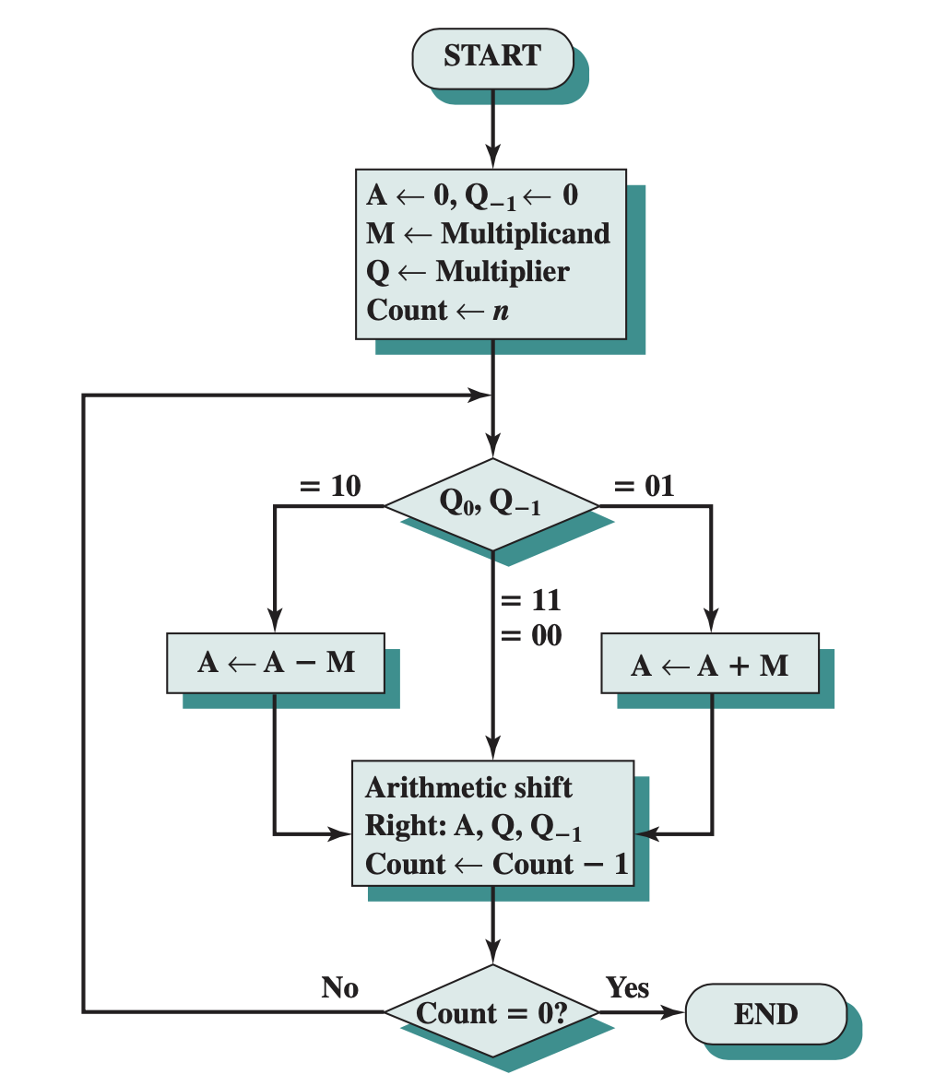

Fig: Booth’s algorithm for 2’s complement multiplication

Booth’s algorithm: 7 (0111) X 3 (0011) = 21
Q = 3 = 0011
M = 7 = 0111
-M = -7= 1001
Count | A | Q (3)₁₀ | Q₋₁ | M (7)₁₀ | Remarks
0 | 0000 | 0011 | 0 | 0111 | Initial values
1 | 1001 | 0011 | 0 | 0111 | Add; A A-M  Arthm. Right Shift
1 | 1100 | 1001 | 1 | 0111 | Add; A A-M  Arthm. Right Shift
2 | 1110 | 0100 | 1 | 0111 | Arthm. Right Shift
3 | 0101 | 0100 | 1 | 0111 | Add; A A+M  Logical Right Shift
3 | 0010 | 1010 | 0 | 0111 | Add; A A+M  Logical Right Shift
4 | 0001 | 0101 | 0 | 0111 | Logical Right Shift

0111 X 0011 = 0001 0101
i.e. (7)₁₀ X (3)₁₀ = 16+4+1 = (21)₁₀

4.6 Unsigned Binary Division Algorithm

**Note: For Unsigned Binary Division and 2’s complement division, find the pdf Integer Division in Landscape.

4.7 Floating Point Representation
The two most common floating-point binary storage formats used by Intel processors were created for Intel and later standardized by the IEEE organization:
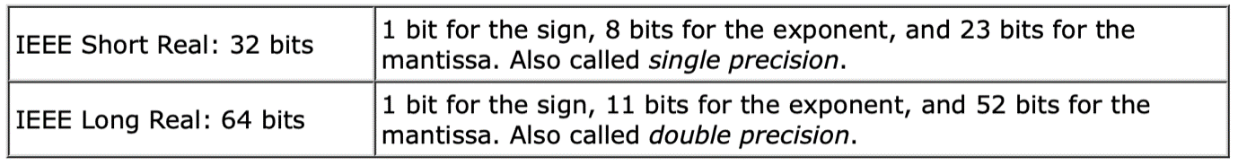
Both formats use essentially the same method for storing floating-point binary numbers, so we will use the Short Real as an example.
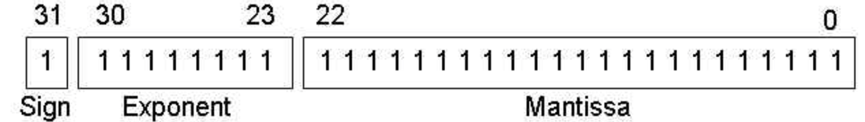
(Significand)
Fig 1: Floating point representation in IEEE Short Real: 32 bits
The Sign
The sign of a binary floating-point number is represented by a single bit. A 1 bit indicates a negative number, and a 0 bit indicates a positive number.
The Mantissa
In the number +11.1011 x 23,
the sign is positive,
the mantissa is 11.1011,
and the exponent is 3.
The Exponent
IEEE Short Real exponents are stored as 8-bit unsigned integers with a bias of 127.
Let's use the number 1.101 x 25 as an example. The exponent (5) is added to 127 and the sum (132) is stored in binary as 10000100.
Here are some examples of exponents, first shown as decimal values, then as biased decimal, and finally as 8- bit unsigned binary:
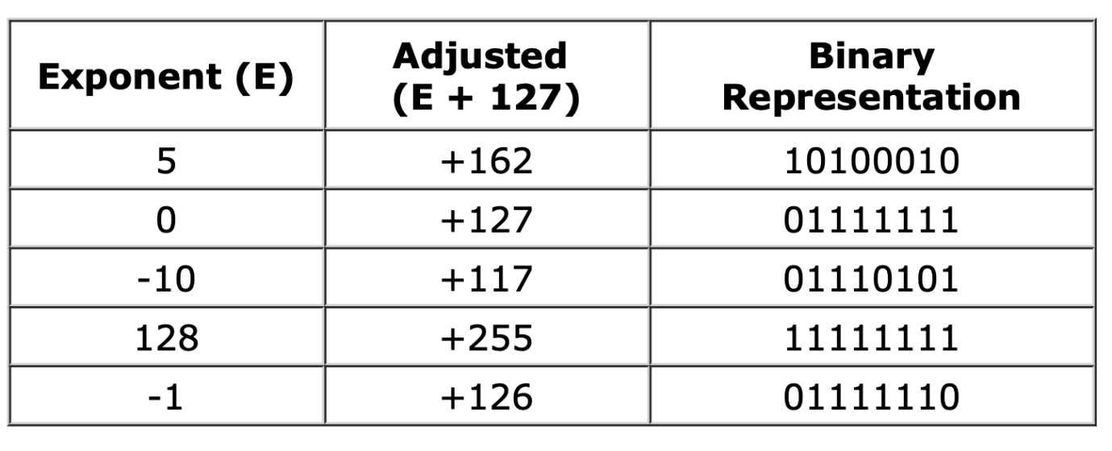
Notice that the binary exponent is unsigned, so it cannot be negative. That is why the bias of 127 is used. The largest possible exponent is 128, because when added to 127, produces 255, the largest unsigned value represented by 8 bits. If the approximage range is from 1.0 x 2-127 to 1.0 x 2128.
Normalizing the Mantissa
Before a floating-point binary number can be stored correctly, its mantissa must be normalized.
The floating-point binary value 1101.101 is normalized as 1.101101 x 23 by moving the decimal point 3 positions to the left, and multiplying by 23.
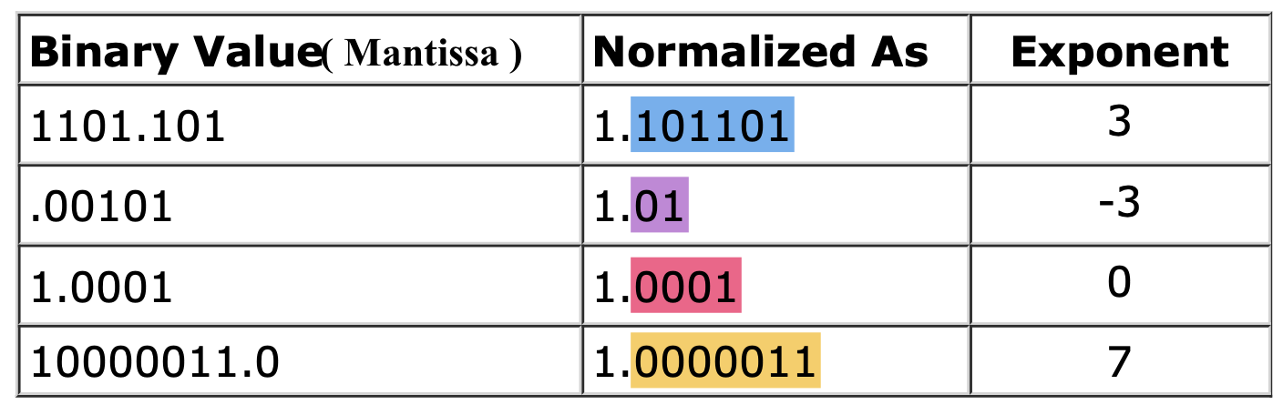
In a normalized mantissa, the digit 1 always appears to the left of the decimal point. In fact, the leading 1 is omitted from the mantissa's actual storage because it is redundant.
Putting it All Together
We have now reached the point where we can combine the sign, exponent, and normalized mantissa into the binary IEEE short real representation. Using Figure 1 as a reference, the value 1.101 x 20 would be stored as sign = 0 (positive), mantissa = 101, and exponent = 01111111 (the exponent value is added to 127). The leading "1." was dropped from the mantissa. Here are more examples:
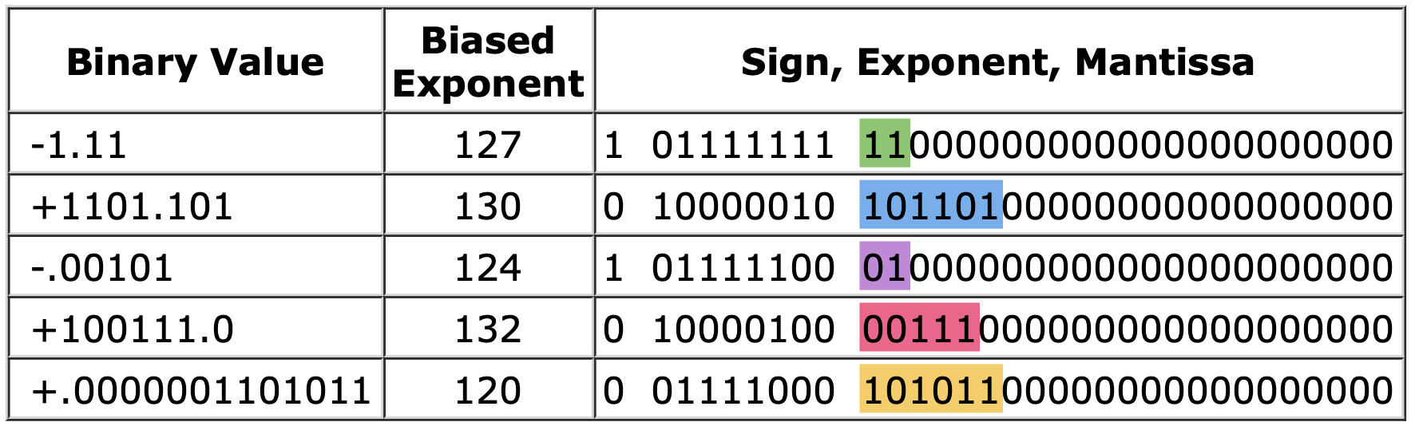

4.7.1 Floating Point Arithmetic

Table: Floating point numbers and Arithmetic Operations
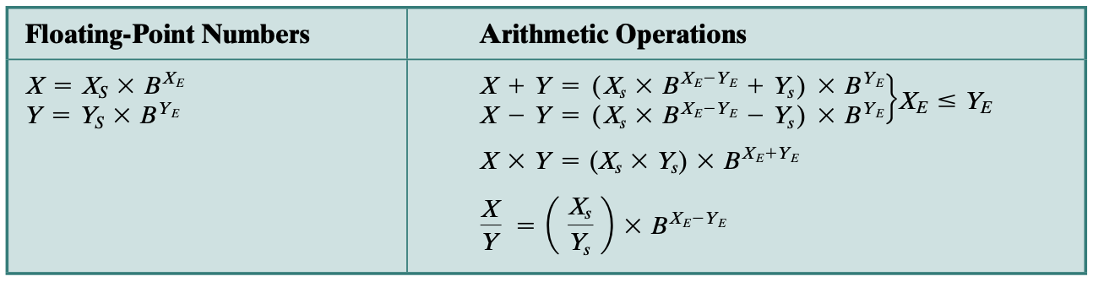
The above table summarizes the basic operations for floating-point arithmetic. For addition and subtraction, it is necessary to ensure that both operands have the same exponent value. This may require shifting the radix point on one of the operands to achieve alignment. Multiplication and division are more straightforward.
A floating-point operation may produce one of these conditions:
  - Exponent overflow: A positive exponent exceeds the maximum possible ex- ponent value. In some systems, this may be designated as + or - .
  - Exponent underflow: A negative exponent is less than the minimum possible exponent value (e.g., -200 is less than -127). This means that the number is too small to be represented, and it may be reported as 0.
  - Significand (Mantissa) underflow: In the process of aligning significands, digits may flow off the right end of the significand. As we shall discuss, some form of rounding is required.
  - Significand(Mantissa) overflow: The addition of two significands of the same sign may result in a carry out of the most significant bit. This can be fixed by realign- ment, as we shall explain.
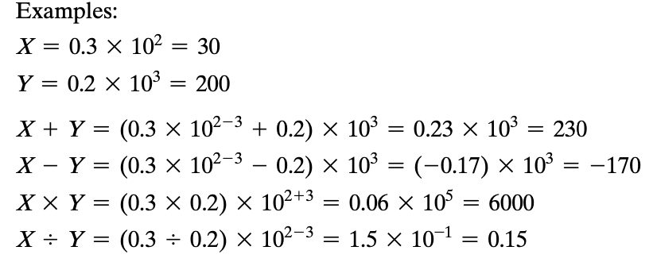
4.7.2 Addition and Subtraction:
In floating-point arithmetic, addition and subtraction are more complex than multiplication and division. This is because of the need for alignment. There are four basic phases of the algorithm for addition and subtraction:
1. Check for zeros.
2. Align the significands (Mantissa).
3. Add or subtract the significands (mantissa)
4. Normalize the result.

1. Check for zeros
Because addition and subtraction are identical except for a sign change, the process begins by changing the sign of the subtrahend if it is a subtract operation. Next, if either operand is 0, the other is reported as the result.
2. Align the significands.
The next phase is to manipulate the numbers so that the two exponents are equal. Alignment may be achieved by shifting either the smaller number to the right (increasing its exponent) or shifting the larger number to the left. Because either operation may result in the loss of digits, it is the smaller number that is shifted; any digits that are lost are therefore of relatively small significance.
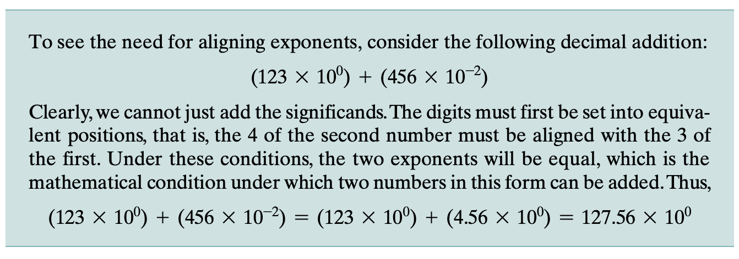

3. Add or subtract the significands (mantissa)
Next,the two significands are added together,taking into account their signs. Because the signs may differ, the result may be 0. There is also the possibility of significand overflow by 1 digit. If so, the significand of the result is shifted right and the exponent is incremented. An exponent overflow could occur as a result; this would be reported and the operation halted.
4. Normalize the result.
The final phase normalizes the result. Normalization consists of shifting significand digits left until the most significant digit (bit, or 4 bits for base-16 exponent) is nonzero.
4.7.2 Multiplication and Division:
4.7.2.1 Multiplication:
- If operand is zero, result is reported as 0.
- Add exponents, if exponents are stored in bias form, then sum would double the bias. Thus, bias value is subtracted from sum. The result is either exponent overflow or underflow. If the exponents are in proper range, the next step is multiplying the significand (manitssa) considering the signs. The case is applicable for both sign and 2’s complement notation. The product will be double the length of multiplier and multiplicand. Extra bits are lost during rounding. The result is then normalized.
4.7.2.2 Division
- If divisor is zero, an error is issued or the result is set to infinity. If the dividend is zero, result is zero.
- Divisor exponent is subtracted from dividend exponent and the mantissa (significand) is divided.
- Exponent overflow or underflow is checked.

Example:
4.8 BCD Arithmetic Unit
BCD ADDER
The most common format used to represent decimal data is called BCD. In BCD notation, a decimal (0 – 9) is represented by 4 – bit (0000 – 1001). For values from 0 to 9 representation are same as in binary. Bits value above 9 (1010 to 1111) are not used in BCD.
Multiple decimal numbers are stored as multiple groups oof 4 – bit per digit.
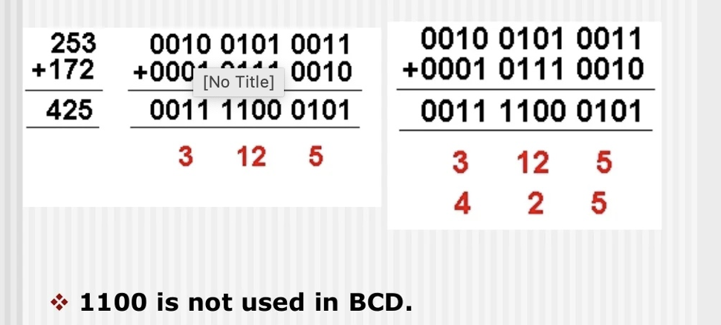
BCD is a signed notation i.e., it can be
$-27$ 0 0010 0111
$+ 27$ 1 0010 0111

BCD Adder is similar to signed magnitude notation as long as the sum of 2 digits do not exceed 9. There are two situations in which error occurs.
When the result is not valid BCD digit.

E.g.: 4 0 1 0 0
$+6$ $+$0 1 1 0
10 1 0 1 0 Invalid BCD
When the result is valid BCD but with carry
E.g.: 9 1 0 0 1
$+8$ $+$1 0 0 0
17 1 0 0 0 1 Valid BCD
In either case adding 6 to the result generated by a binary adder produces the correct result.

Note: 6 (0110) is a binary pattern that is unused in BCD representation
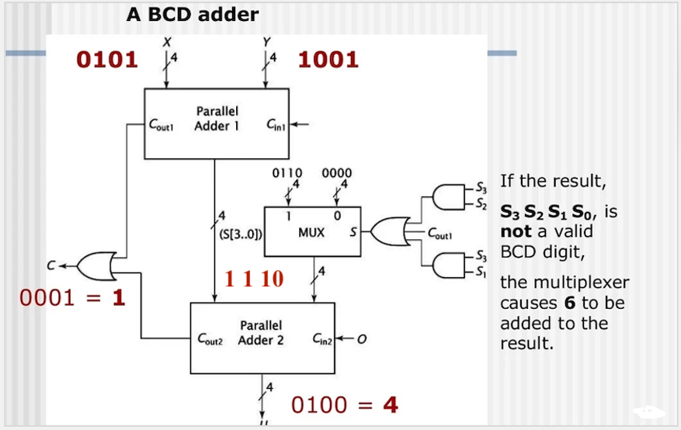
Fig: A BCD ADDER
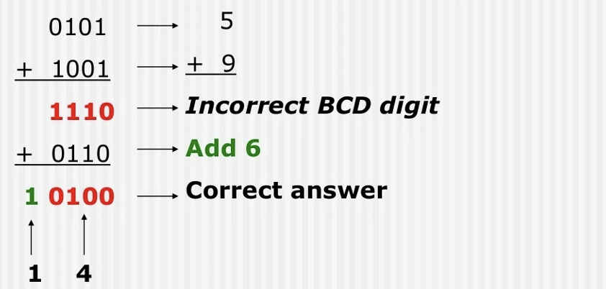
In the above figure, two digits X and Y are first added together then this result is added to 0 or 6 to produce correct BCD sum. If the result is invalid BCD, $S_{3}$ & $S_{2}$ or $S_{3}$ & $S_{1}$ will produce 1. In this case, MUX control bit is set to 1 which causes 6 to be added to the output of parallel adder 1. The output of 4 bit parallel adder 2 (0100) and the carry out 1 (0001) together gives us the correct output 14 as shown in the figure. Multiple copies of this hardware can be cascaded by connecting this carry out / carry in signals to form a multi – digit BCD adder.

2nd example for BCD Adder
E.g.: 9 1 0 0 1
$+8$ $+$1 0 0 0
17 1 0 0 0 1 Valid BCD

Carry out of
Parallel adder 1.
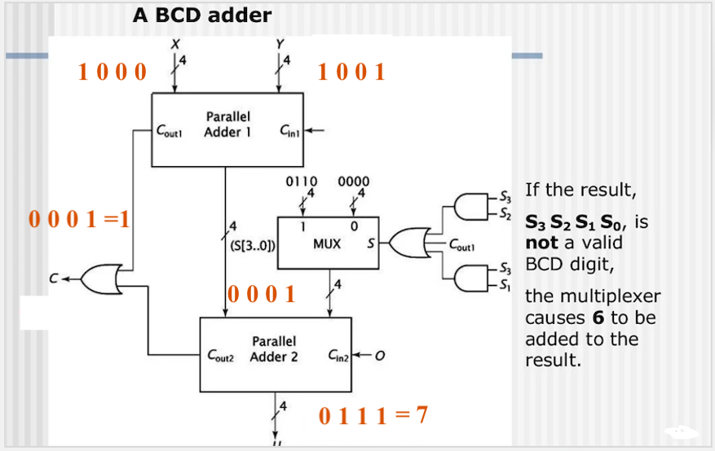

4.9 Arithmetic Pipelining
Arithmetic Pipeline:
An arithmetic pipeline divides an arithmetic problem into various sub problems for execution in various pipeline segments. It is used for floating point operations, multiplication and various other computations. The process or flowchart arithmetic pipeline for floating point addition is shown in the diagram.
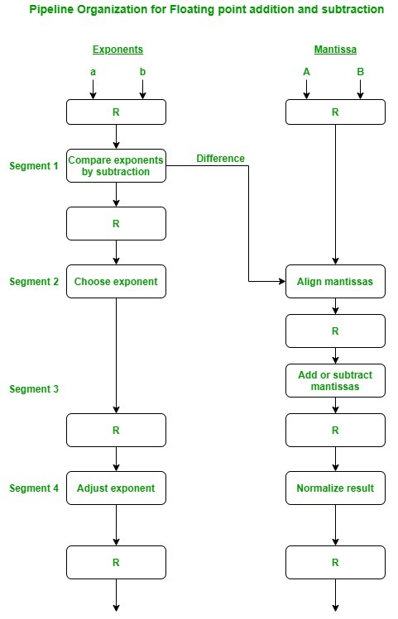

Floating point addition using arithmetic pipeline:
The following sub operations are performed in this case:
- Compare the exponents.
- Align the mantissas.
- Add or subtract the mantissas.
- Normalize the result
First of all, the two exponents are compared and the larger of two exponents is chosen as the result exponent. The difference in the exponents then decides how many times we must shift the smaller exponent to the right. Then after shifting of exponent, both the mantissas get aligned. Finally, the addition of both numbers take place followed by normalization of the result in the last segment.

